Homework 1a

Import data into database

In this homework, you need to import the data (2008Christmas.csv) into the database

Follow the steps below:

1. Login NCTU CS MySQL service ( [https://www.cs.nctu.edu.tw/cscc/mysql/index.php](https://l.facebook.com/l.php?u=https%3A%2F%2Fwww.cs.nctu.edu.tw%2Fcscc%2Fmysql%2Findex.php&h=NAQEKZAxA) )
2. Import the csv dataset ( The first line contains the column names )

The default layout is column-majored, you need to change the settings to row-majored:

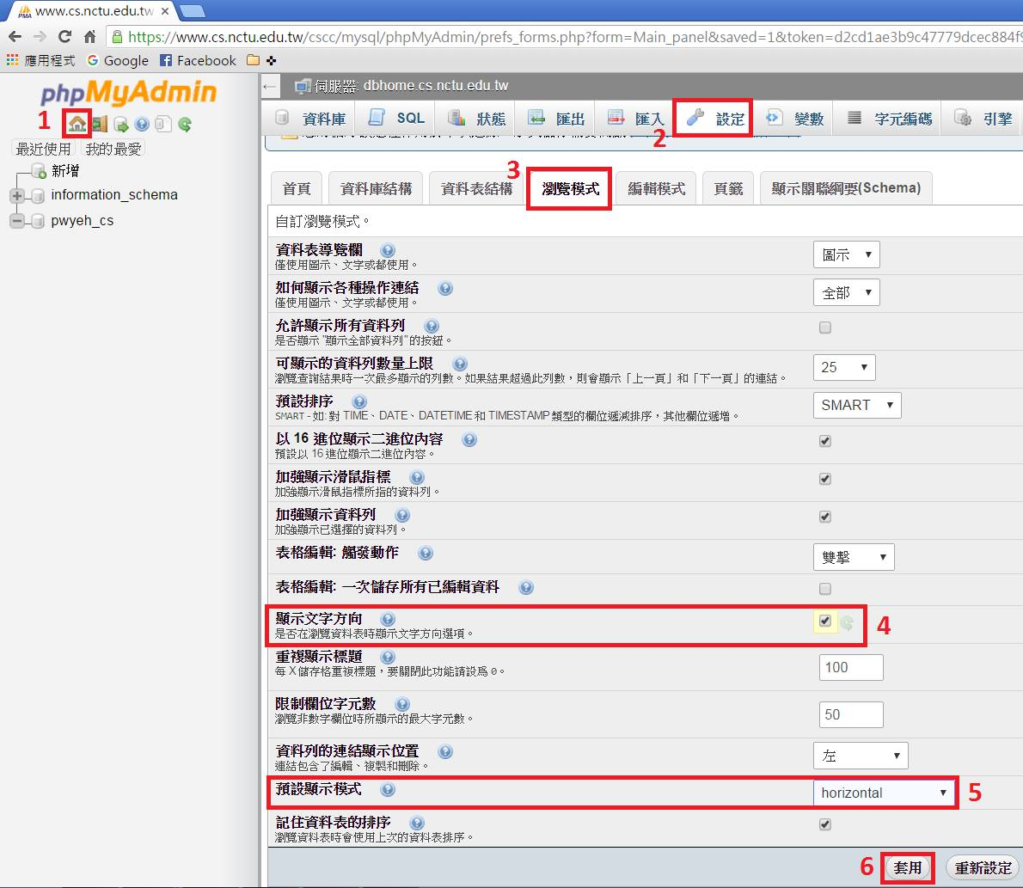

Submission:

Please take a screenshot of the screen (like the figure) and upload it to e3.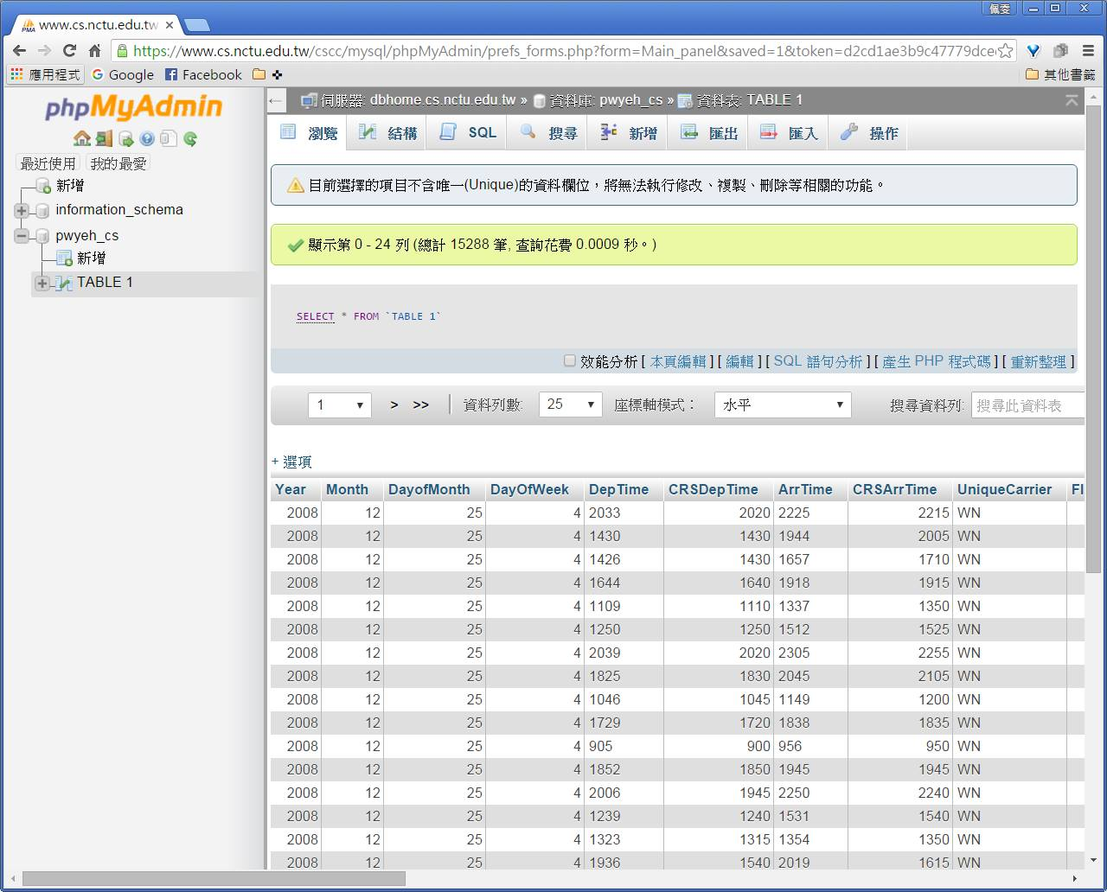

Deadline:

* 2016/4/1 23:59